January GATE Group-“The Dog Poop Initiative”
I bet you are wondering what in the world Mrs. B. has up her sleeves this time, right? I mean what kind of a lesson can there be in dog poop? And how can it be an “Initiative?”
Well, let me tell you “The True Story.”
I bought a book called, “The Dog Poop Initiative” a few years back. I was intrigued by the title, and after I read it, I knew it had an important lesson for my students.

Before reading the book, I picked up all of my GATE students and we took a stroll around NGES’ hallways. The kids saw me stopping and picking up boots, snowpants, scarves, etc… and putting them where they belonged. They saw me picking up garbage, bags, etc…. and again, taking the “initiative” to put these items where they belong. After a little while, all of the students started cleaning up the hallways with me.

Once we were finished strolling throughout the building, we sat down together and read this book. Here is a synopsis.

“The Dog Poop Initiative” was by Kirk Weisler. Below is a Kirk Weisler’s explanation of the book and how he was inspired to write it:

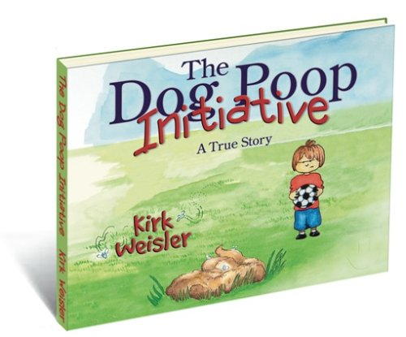
This book was inspired by an event that took place in the summer of my life as a soccer coach and dad. My family and I showed up to the soccer field where my five-year-old son was going to play, and as the two previous teams finished up. As our boys gathered, some helpful parents from the already playing teams pointed out a large pile of Dog Poop on the field, and warned us to point it out to our boys. A few moments later, the coaches of the departing teams also pointed out the poop, and gave us the same admonition. Next came the referees assigned to the field for the evening, who told us the same thing! After this third warning, my son’s other coach and I looked at each other and, without saying a word, turned and went to separate trash cans on the field in search of something we could use to scoop up the poop. We found a large piece of cardboard, and had it cleaned off the field in less than a minute. I still remember some of the dumbfounded and bewildered expressions of the "Adults" who had so helpfully pointed it out – but who, apparently, had never considered actually cleaning it up! As I viewed all the parents that lined the field, and pondered all the parents and coaches who had been there throughout the day – each one dutifully and diligently passing along the "Poop Warning" – I marveled that NONE had taken the initiative to clean it UP! What an opportunity to teach, by example, the important principles of service, teamwork, selflessness, and INITIATIVE. In my mind’s eye I could envision each of these adults ten to fifteen years in the future, lamenting how their own teenagers don’t take initiative nor even understand what it is! Sadly, I would guess that even then, it will not occur to these "pointing parents" that a large portion of what their teenagers don’t do is a direct result of never having seen their parents do it. My rough calculations put the estimate at a potential 220 plus Adult Poop Pointers – and only 2 Poop Scoopers! With the Initiative Bar so low, those of us who are willing to take it end up looking like high jumpers. But what an opportunity to show our children how they, too, can effect change by taking initiative! As I relayed this story to colleagues and friends, I found that a tremendous amount of people are just as upset, or more so, as I am with the lack of initiative in society. The ever-growing mindset of "It’s not my job," or "Someone else will do it," plays itself out all too often in myriads of ways that impact each of us on a daily basis. The response to the story was so strong that I included it in my next few speaking engagements. Some people even told of using the story in staff meetings. All that led to final publication of The Dog Poop Initiative. I hope you enjoy it!

After reading the book to the students, we chatted about “initiative” and how true leaders were initiators of positive changes in our world. We discussed how the GATE students could be the “initiators” of great things happening at NGES, and that each student could partner with another classmate to be partners in initiating helpfulness at our school.

WE took “The Dog Poop Initiative” and made it “The NGES GATE Kid’s Initiative”, and I do believe that your children learned not be “pointers”, but to be “scoopers and heroes” today!!!

